APPROVALS AND MANAGING APPLICANTS

July 1, 2015
  - User Guide

INTRODUCTION

PeopleAdmin Web Address
https://unk.peopleadmin.com/hr/sessions/new

PeopleAdmin supports the following browsers:
- Chrome
- Firefox
- Internet Explorer version 9+
- Safari
PeopleAdmin requires you to have Adobe Acrobat Reader. This is a free download available at www.Adobe.com.

Log-In Screen
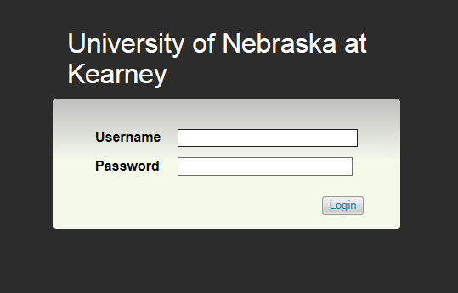
Username: First part of email address (i.e. smithaj)
Password: EASI / Computer & Email Password

Home Screen
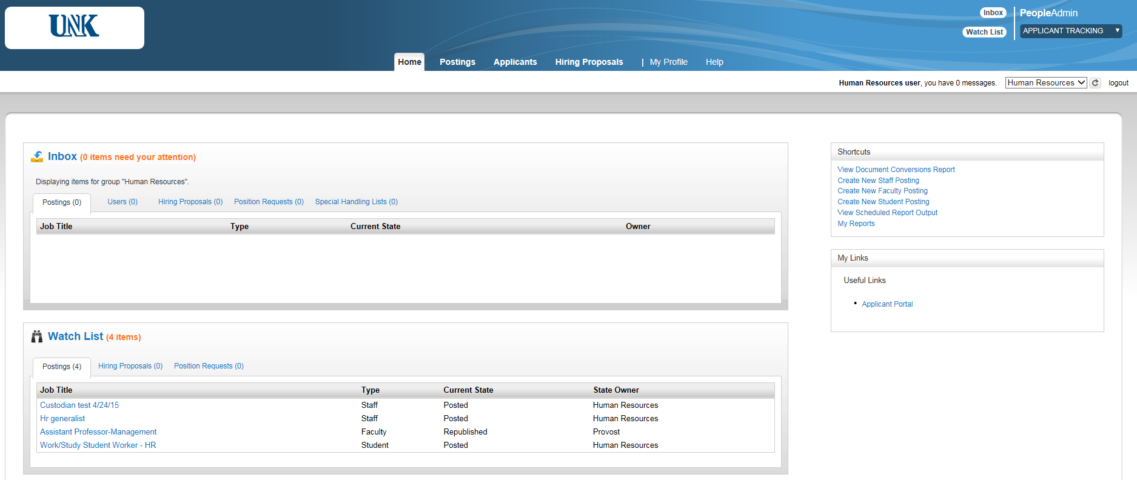
6..
5..
4 ..
3..
2..
1..
Note: If changing user roles, select desired role from drop down in the upper right-hand corner and click to confirm change

1 | Inbox | Items which require your attention
2 | Watch List | Items you would like to watch as they move through the approval process
3 | Tabs | Navigate between postings, applicants, etc.
4 | Shortcuts | Quick links to important areas (i.e. create a staff posting)
5 | My Links | Links to useful external websites
6 | Current Role | Change to correct role (Search Chair, Dean/Department Head, etc.)

APPROVALS

Approvals for postings and hiring proposals are built in to the PeopleAdmin system. Once approved by the previous approval level, an email will be generated to the next person(s) in the approval workflow.

Approving Postings
Step 1: Log-in to PeopleAdmin; the Posting will show in the Inbox. If it does not show in your inbox, hover over the Postings tab and click on the appropriate position type. You will see all Postings you are assigned to.
Step 2: Make sure that you are in the correct user role for the approval you are completing. To change user roles, select desired role from drop down in upper right-hand corner and click to confirm change.
Step 3: Click on the posting and review carefully. There will be some sections that are not necessary for all approvers to review in order to approve their specific portion. Each posting should contain supplemental questions, interview questions, reference questions, evaluative criteria, long and/or short advertisements, and names of the search chair and search committee members.
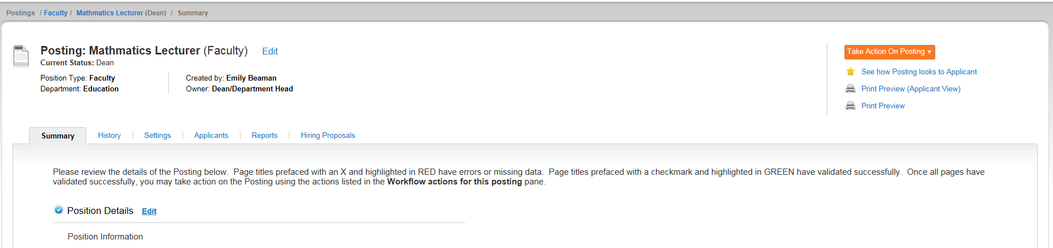
Step 4: After reviewing the posting, return to the summary page, and hover over and select the appropriate workflow step. If there is more than one option, and you do not know which one to choose, please contact HR. You can also select Keep Working on this Posting if you are not ready to approve the posting, or if you need to make changes.
Step 5: Add comments if needed and click Submit.

Approving Hiring Proposals
Step 1: Log-in to PeopleAdmin; the Hiring Proposal will show in the Inbox. If it does not show in your inbox, hover over the Hiring Proposals tab and click on the appropriate position type. You will see all Hiring Proposals you are assigned to.
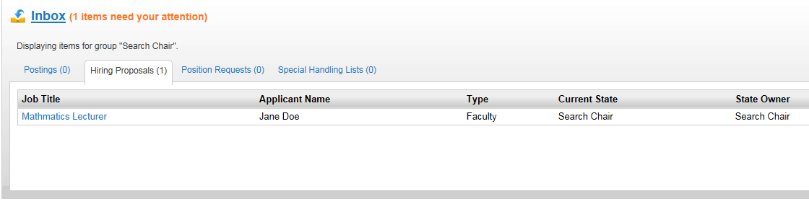
Step 2: Make sure that you are in the correct user role for the approval you are completing. To change user roles, select desired role from drop down in upper right-hand corner and click to confirm change.
Step 3: Click on the Hiring Proposals tab, then click on the Position you are approving.
Step 4: After reviewing the Hiring proposal, hover over and select the appropriate workflow step. If there is more than one option, and you do not know which one to choose, please contact HR. You can also select Keep Working on this Hiring Proposal f you are not ready to approve, or if you need to make changes.
Step 5: Add comments if needed and click Submit.

VIEWING APPLICATIONS

When an application is submitted, it will be routed to Human Resources. HR will release the applications to the search committee for review and notify the Search Chair through email that new applications are viewable.

Viewing All Applicants
Step 1: Log in to the PeopleAdmin system and make sure you are in the correct user role, i.e. Search Committee Member or Search Chair. To change user roles, select desired role from drop down in upper right-hand corner and click to confirm change.
Step 2: Hover over the Postings tab and click on appropriate position type (Staff, Faculty, Student). You will see a list of all postings you are assigned to.
Step 3: Hover over and click View Applicants. You will see a list of all applicants who applied for the position. You can add additional columns to your search by creating a customized search (see Search Functions) Note: If you used a disqualifying supplemental question for the posting, disqualified applicants will not appear to the search chair or search committee. This information is only viewable to HR.

All Applicants Screen
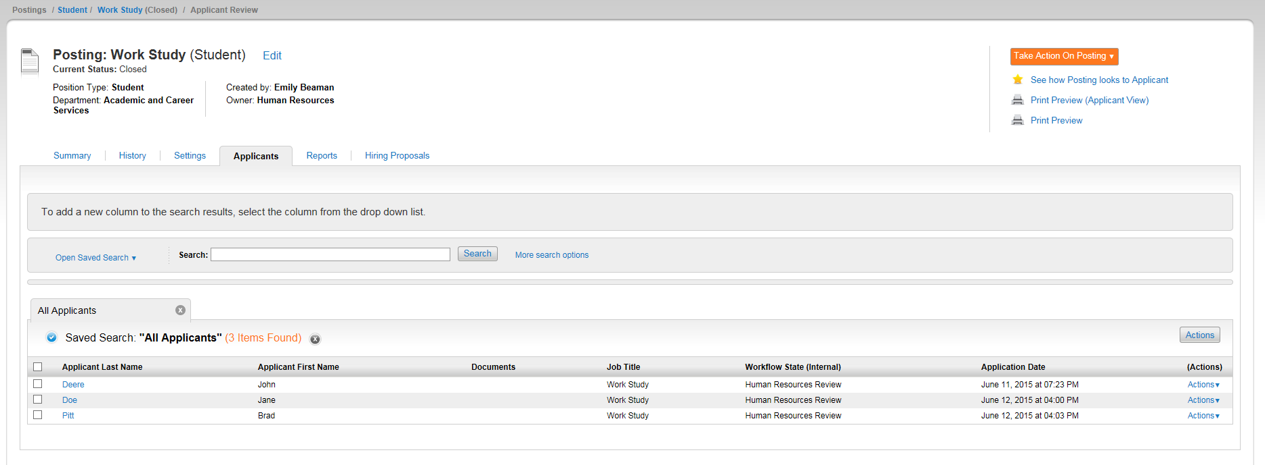
From the All Applicants Screen (shown above), you can view applicants individually or view several applications at a time.

Viewing a Single Application
To view an applicant individually, click on Applicant’s name or hover over and Click View Application

Viewing Multiple Applicantions
You can review more than one applicant document at a time. You may choose to view specific documents for a group of applicants, or all applicant documents for a group of applicants.

Step 1: Check each box for the applicants you wish to view
Step 2: Hover over the button that is located above. You should see the following options in the Bulk Section:
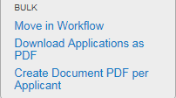
Step 3: Click Download Applications as PDF (one document for all applicants) or click Create Document PDF per Applicant (separate document per applicant)

Other Ways to Manage Applicants
Search Committee Members can Evaluate Applicants, Review Answers to Supplemental Questions, Download Screening Question Answers (Excel Document), and Export Results (Excel Document).
Search Chairs can also Download Applicants Evaluations (view results of all evaluative criteria submitted by search committee members to Excel Document).
To complete any of these functions, hover over the button that is located above and click on desired function:
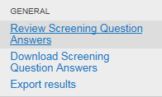

Evaluate Applicants
Search Committee Members and Search Chairs can rate each applicant. The Search Chair will be able to see responses from the entire committee.
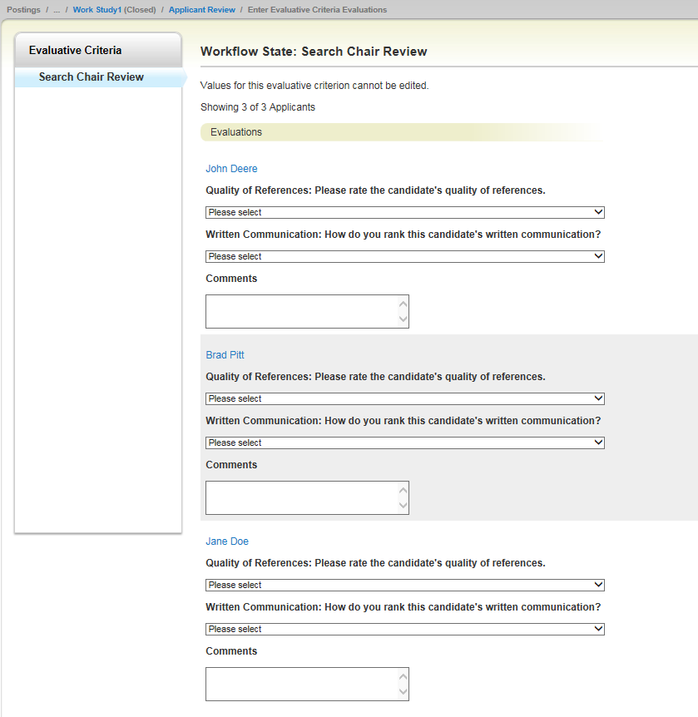

Reviewing Screening Question Answers
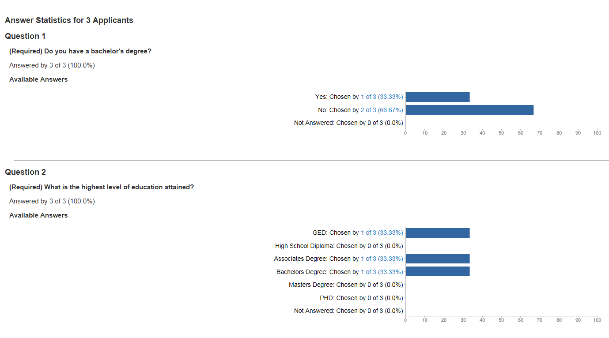
From here, you can click on each response to see who the name of the applicant who chose the response by clicking on the words highlighted in blue. Scroll to the bottom of the page and the names of the individuals who chose that response appear.
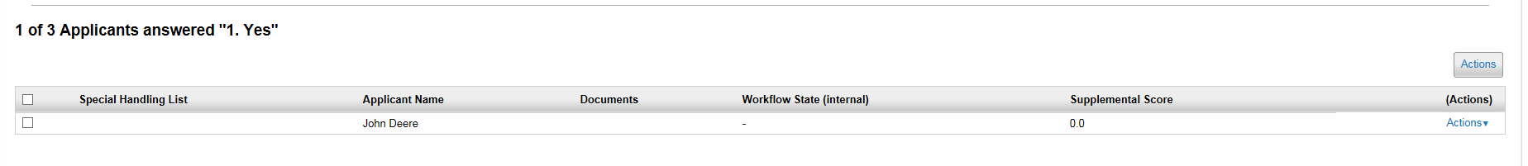
If you would like to search for a specific combination of responses, hover over and click Search Answers. Select the question and the desired answers, and click Search.

Download Screening Question Answers
First Name | Last Name | Username | Special Handling | Question 1. Do you have a bachelor's degree? | Question 2. What is the highest level of education attained? | Overall Score
John | Deere | jdeere |  | Yes | Bachelors Degree | 0
Brad | Pitt | bpitt |  | No | Associates Degree | 0
Jane | Doe | Test 1 |  | No | GED | 0

MOVING APPLICANTS TO NEW WORKFLOW STATE

The search chair can move applicants to new workflow states individually or move several applicants at the same time.
Be very careful when moving applicants to Not Interviewed, Not Hired or Interviewed, Not Hired. Once this workflow step is selected and a disposition is chosen, the applicant receives and email from PeopleAdmin immediately notifying the applicant that they were not selected for hire.

Moving an Applicant to a New Workflow State
Step 1: Click on Applicant’s Name or hover over and click View Application
Step 2: After reviewing applicant, hover over and select appropriate workflow action

Further Review | Applicant in further review status and allows you to keep applicant active in search if you might return to applicant later on
Interview | Applicant is selected for an interview
Finalist Review | Applicant is one of 2 or 3 candidates selected as finalist and will be sent to HR for approval
Recommend for Hire | Applicant has been interviewed and approved as a finalist (Applicant must be moved to the workflow state in order to begin a Hiring Proposal)
Interviewed, Not Hired | Applicant chosen for interview, but not selected for hire - will get email once dispositioned with reason why not hired
Not Interviewed, Not Hired | Applicant was not selected for interview - will get email once dispositioned with reason why not hired
Withdrawn | Applicant notified department or HR to withdraw application
System Does Not Meet Minimum Qualifications | Do not select
Special Handling List | Do not select

Step 3: If you select Not Interviewed, Not Hired or Interviewed, Not Hired, you will have to select a disposition reason

Moving Multiple Applicants to a New Workflow State
Step 1: Carefully review all applicants and determine which applicants you would like to interview, keep for further review, etc.
Step 2: From the All Applicants Screen, select the applicants you would like to move by clicking the box to the left of their name
Step 3: Hover over the button that is located above
Step 4: In the Bulk Section, click on Move in Workflow
Step 5: On the next screen you can select to move all applicants to a new workflow state or move applicants individually
Step 6: If you select Not Interviewed, Not Hired or Interviewed, Not Hired, you will have to select a disposition reason. If you select Finalist Review, these applicants will be sent to HR for approval
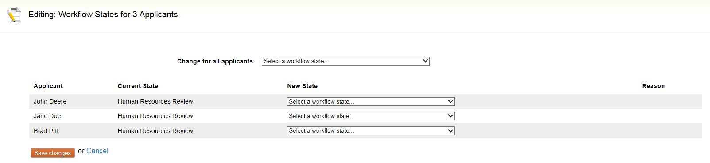

FINALIST REVIEW

Once you have completed interviews and narrowed the pool of applicants to 2 or 3 finalists, these applicants will be need to be reviewed by HR

Step 1: From the All Applicants Screen, select the applicants you would like to move by clicking the box to the left of their name
Step 2: Hover over the button that is located above
Step 3: In the Bulk Section, click on Move in Workflow
Step 4: Select Finalist Review. At this time HR will let the search chair know if any applicant elected the Nebraska Veterans Preference.

HIRING PROPOSALS

Once an applicant is interviewed and approved as a finalist, the search chair can begin a hiring proposal.
Step 1: Select the desired applicant
Step 2: Hover over and select Recommend for Hire
Step 3: On the Applicant’s summary page, click Start Hiring Proposal

Step 4: Complete the information in the Hiring Proposal. The applicant and position information will be read only. List a short reason why the applicant was selected for hire. Remember: this information remains in the search file can be viewed later.

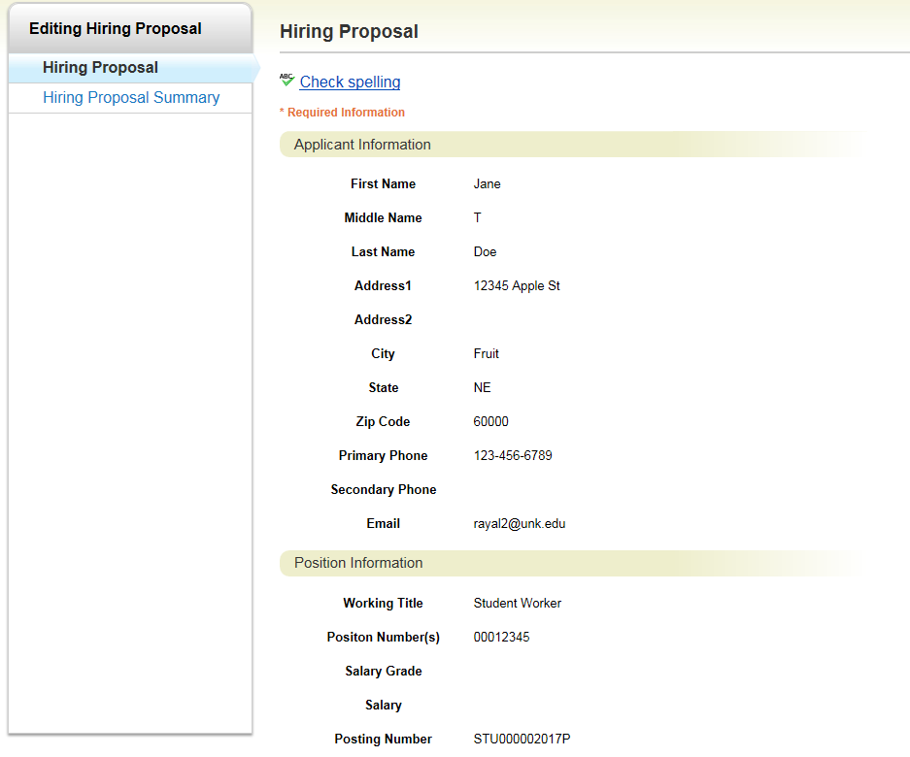
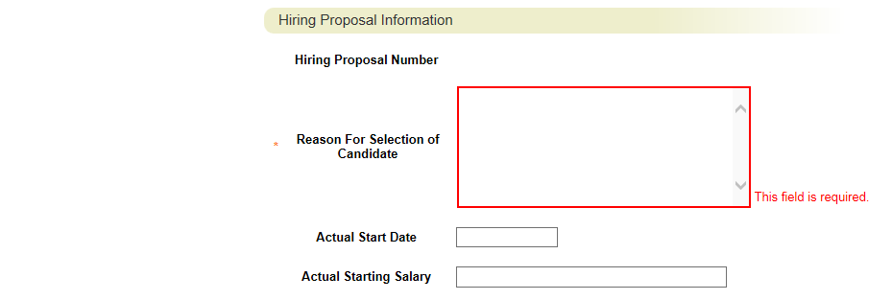
Click

Hover over and select Hired: Pending Acceptance. The Hiring Proposal will then go through several approvals.

Final Steps
Human Resources is the final step for the hiring proposal. Once approved by HR, the department can make a verbal offer pending a successful background check. After the verbal offer if accepted, HR will send the applicant Background Check paperwork. If the Background check is successful, the applicant will be moved to Hire Approved.

Once a candidate has accepted the position and completed a successful background check, the search chair needs to disposition the remaining candidates. HR will mark the posting as Filled.

SEARCH FUNCTIONS

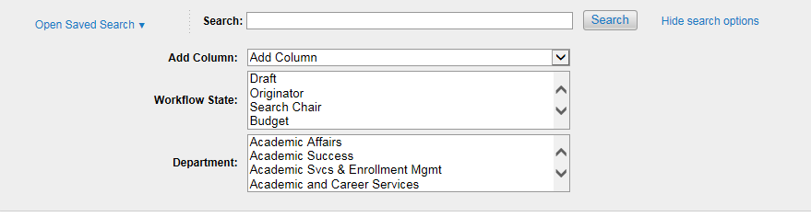
2..
5..
4..
3..
1..
1 | Search Box | Search specific words or names
2 | More (Hide) search options | Expand or collapse search tools area
3 | Add Column | Add additional column if information is not included on search results
4 | Workflow State | Search for applicants or postings only in specific workflow states
5 | Department | Search for postings only for specific departments

Use the column controls to organize and sort the search results. You can customize your search results based on how you wish to view the data – See Create a Saved Search. Organize the information by using the column controls. To adjust column controls, hover near the far right-hand side of the column you are adjusting and click the appropriate symbol:

< or > | Move column left or right
or | Reorder the search results in ascending or descending order
X | Delete column

Search Tips
- Text search is not case sensitive.
- Searches normally return items that contain all your search terms. For example, if you enter facilities manager, the search returns items that contain both these words.
- To exclude search results, use the – or ! characters. For example, to search for postings that contain the word "director" but not "athletic", enter director !athletic or director -athletic, placing a space before the ! or - character.
- To search for a phrase that contains a dash or a space, enclose the entire phrase in quotation marks: "director - athletic".
- You can't do a search that only specifies what not to return, such as !coordinator.
- You can't do a search for a word or phrase that was selected from a drop-down list, such as the name of a state, but you can use filtering to find the information. The procedure below for viewing applicants who reside in a specific state gives an example of how to do this.

Applicant Search
Step 1: Hover over the Applicants tab and select Applicant Search
Step 2: Click More search options to expand the search tools area.
Step 3: Use the searching and filtering tools to narrow down the results

Export Search Results
- Set up the search or open a saved search.
- From the Actions menu, select Export Results. The search results are as an Excel document.

Creating a Saved Search
When you save a search, you have the option to set it as your default search. This is your only opportunity to set it as the default search.
People with administrative access can share saved searches by tagging them as global or group saved searches. Non-administrative users can only save personal searches.
Step 1: After you have used the search and filtering controls to present the search results the way you want to see them, select Save this search. The Saved Search area expands.
Step 2: Give the search a name that will help you remember its purpose.
Step 3: Select one of these:
Personal Saved Search – Only you will have access to this search.
Group Saved Search – The search will be available to all users within the groups that you specify. Select at least one group from the list that appears when you select the Group Saved Search option. To select more than one group, hold down the Ctrl key while you select the groups.
Global Saved Search – The search will be available to all users within your organization.
Step 4: If this search presents the information you will normally want to see when you navigate to this page, you may want to select Make this the default search.
Step 5: Select Save this search. The search tab refreshes to present the name you have given the search. This tab remains available for the rest of your session. The next time you log in, the search is available from the list of saved searches in that area.

